

**SUSTAINABLE OUTREACH AND UNIVERSIAL LEADERSHIP LIMITED (SOUL)**

This document contains information that is proprietary and confidential to SUSTAINABLE OUTREACH AND UNIVERSIAL LEADERSHIP (SOUL) LIMITED, Odisha, India and it shall not be disclosed outside and shall not be transmitted, or duplicated, used in whole or in part for any purpose other than its intended purpose. Any use or disclosure in whole or in part of this information without written permission SOUL Limited is prohibited.



BADRI RAI CONSTRUCTIONS

PVT. LTD.

FOR

ERP Implementation Proposal

**Statement of confidentiality**

This document contains information that is proprietary and confidential to SUSTAINABLE OUTREACH AND UNIVERSIAL LEADERSHIP (SOUL) LIMITED, Odisha, India and it shall not be disclosed outside and shall not be transmitted, or duplicated, used in whole or in part for any purpose other than its intended purpose. Any use or disclosure in whole or in part of this information without written permission SOUL Limited is prohibited.

Table of Contents

**1.****Executive Summary** 3

1.1 Context 3

1.2 Why Construction ERP? 3

**2.****Introducing SOUL Limited** 4

**3.****Our Understanding of Key industry processes.** 5

**4.****How ERP will help BRC** 5

**5.****Construction ERP – Technology Architecture** 6

**6.****Construction ERP– High Level Scope** 6

6.1 Engineering (BBS, Unit Conversion Factor, Detailed Material Specifications): 6

6.2 Estimation, Bidding & Tendering: 6

6.3 Project Management System (BOQ, WBS/PBS, DPR, MB, RA Bills) : 7

6.4 Document Management System with workflow 7

6.5 Fixed Assets & Maintenance (Tools & Plants): 7

6.6 Stock Module 7

6.7 Finance & Accounting: 7

6.8 Human Resource Management 7

6.9 Payroll 7

6.10 Accounting Modules 7

6.11 Materials Management 8

6.11.1 Stock & Bill & Payment Entry 8

6.12 Other Features 8

**7.****Delivery methodology** 10

**8.****Construction ERP - Commercials** 11

**9.****Terms & Conditions** 12

### **Executive Summary**

Badri Rai Construction company(BRC) is a construction company based out of Noida. They would like to invite proposal for implementing an enterprise resource planing software for multiple modules in one of their sites in Assam.

SUSTAINABLE OUTREACH AND UNIVERSIAL LEADERSHIP (SOUL) Limited proposes to implement ERP for construction (a cloud based ERP solution for Engineering and Construction industry) at BRC Assam Site. Construction ERP is a complete solution to manage every operation of an small to medium size firm like Project Management, Human resource management, Finance and accounting, payroll management, materials management and inventory management etc.

This proposal document includes technical architecture, module highlights and commercial details for implementation of Construction ERP solution at BRC.

## Why Construction ERP?

ERP Construction is a cloud based ERP solution specifically designed for Engineering and Construction industry/firms based on deep understanding of the processes using best practices. The system works right out of the box. If the client prefers, the system can be hosted by SOUL Limited on its cloud servers so that the client don’t have to worry about the hardware or its maintenance.

The advantages of using Construction ERP include:

|  |  |
| --- | --- |
| Robust Customization | User Friendly |
| * Low-Cost Customization * Bulk data import facility * SMS, Payment Gateways and Bio metric System Integration Options available | * Access to a forum common to students and parents * User friendly interface requiring minimal prerequisite knowledge * Effective communication between teachers and students |
| Dynamic Automation & Support | Security & Surveillance |
| * Completely automated, accessed from anywhere in globe * Dynamic reports, customizable for institution needs * Support round the clock | * VAPT & SAST certified * Cloud based solution * Design for unproblematic scalability |

### **Introducing SOUL Limited**

ERP software for various domains has been developed by SUSTAINABLE OUTREACH AND UNIVERSIAL LEADERSHIP (SOUL) Limited. SOUL Limited is a company formed by a team of professionals having extensive experience in both running educational institutes and technical and management consulting organizations. It has its headquarter at Bhubaneswar, Odisha.

Apart from ERP , SOUL Limited executes Strategy Consulting for Business transformation focused on sustainability through operational efficiency and capital productivity; using delivery process realignment, skill restructuring, smart negotiation, and contracting.

Our Insight:

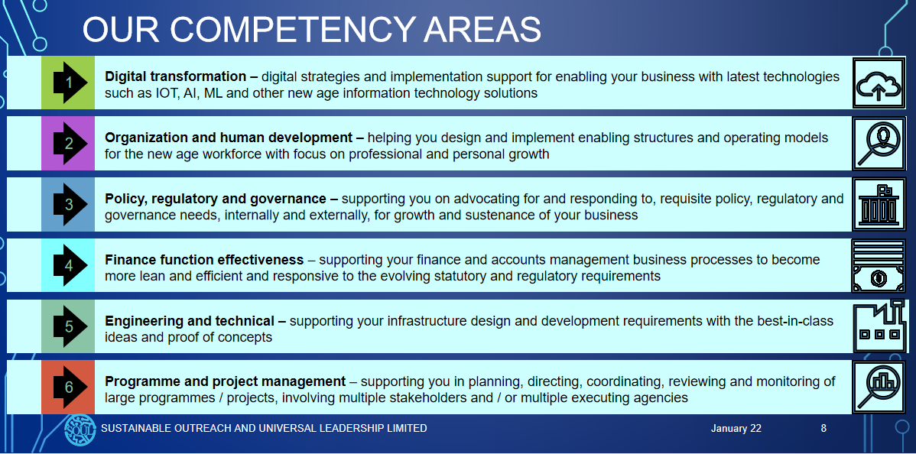

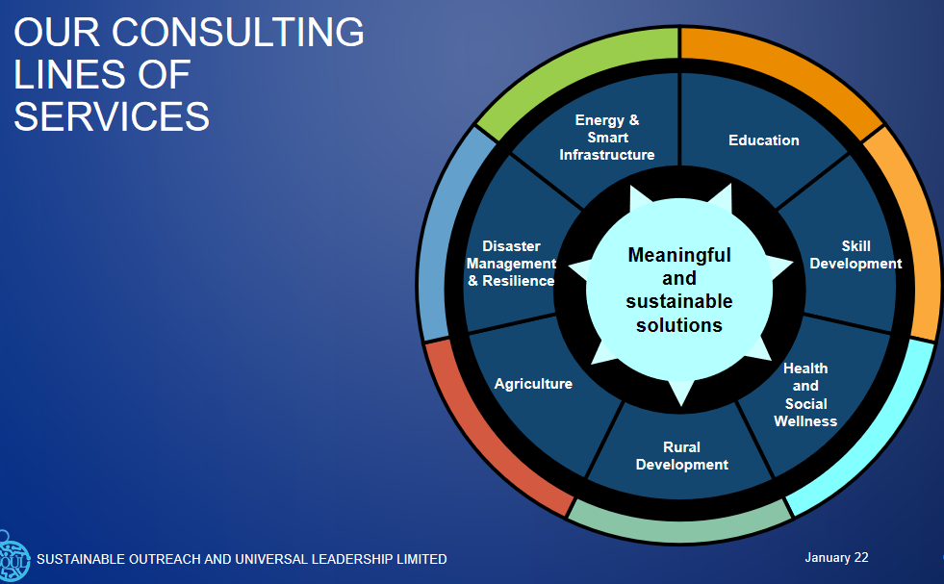

### 

### **Our Understanding of Key industry processes.**

* Initiation: Presales, Bidding, Tender, Contract, Legal ,Plan Approval, Design
* Execution: Operation management, Project Handling, Procurement
* Monitoring: Quality control, Vendor and Sub contractor management
* Closure/Delivery/Registration: Project closure and Accounting, Compliance management
* IT/Product Support: ERP implementation and post roll out support, Reporting

### 

### **How ERP will help BRC**

* Tender: Bid submission, comparative analysis.
* Finance management: Online Payment, Account management.
* Asset Management: Asset tracking, Material management, Procurement management, Energy and Pollution monitoring, Asset movement
* Workforce Management: Sub contractor management, Vendor Management, Labour management, Project planning and execution and monitoring
* IT support: Engineering Design digitization, Online bidding and compliance management.

### **Construction ERP – Technology Architecture**

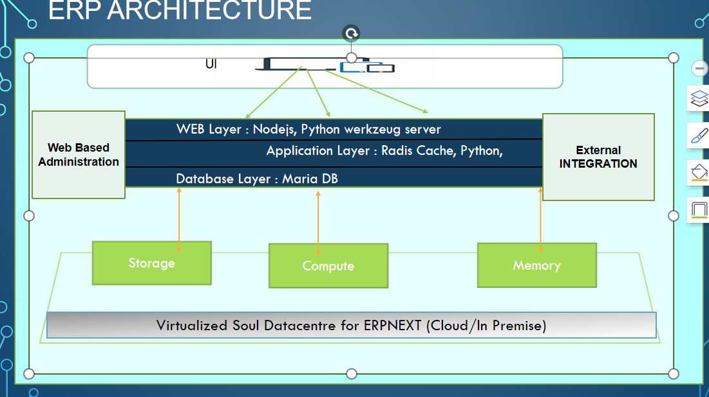

The proposed solution addresses the following design considerations:

* Security: Role based authorization, API security, Session management ,De coupled database, Production Mode for high security setup
* Performance: Caching, Light weight code base
* Ease of Deployment: GitHub integration, Cloud based deployment, patching
* Ease of customization: MVC architecture with decoupled UI/Application/Database.

### **Construction ERP– High Level Scope**

Following is the high level scope of modules proposed to be developed and deployed at the BRC Site Assam. The actual scope and breakdown of modules to individual components will be carried out post due diligence phase after discussing with BRC SMEs.

## Engineering (BBS, Unit Conversion Factor, Detailed Material Specifications):

* Engineering Design storage
* BOM
* Contract and Scope ->Design Drawing -> Tender ->Construction -> Quality control -> Commissioning

## Estimation, Bidding & Tendering:

* Pre Tender
* Tender Opening
* Tender Evaluation

## Project Management System (BOQ, WBS/PBS, DPR, MB, RA Bills) :

* Task Tracking
* Construction Phase wise progress monitoring
* Phase wise dashboard with cost estimate/critical areas requiring attention
* RA bill generation

## Document Management System with workflow

* Upload drawing and other documents and add meta data, tagging
* Integration with multiple modules and workflow system
* Route documents with multiple departments and capture metadata.

## Fixed Assets & Maintenance (Tools & Plants):

* Asset value depreciation
* Asset tagging & disposal
* Integration with GL

## Stock Module

## Finance & Accounting:

## Human Resource Management

* Employee Database
* Employee Register
* Service Book – Promotion, Increment, Transfer etc.
* Attendance & Duty Allocation

## Payroll

* TAX
* SALARY

## Accounting Modules

* Purchase Invoice
* Accounts Payable
* **Bank Statement**
* **Tax & GST:**
* **GST Purchase Register**
* **Financial Accounting**

**Accounts Setup**

* Payee Master

**Accounts Transactions**

* Advances & Settlement

## Materials Management

* **Inventory Management**
  + Stock Ledger
  + Stock Balance
* **Purchase**
  + Item
  + Item Group

# Stock & Bill & Payment Entry

Goods Receipts Note (GRN) can be generated from the system which is basically **Stock Entry** in the system. This system also helps to make voucher/Bill entry against a GRN to initiate the payment process.

* + Stock Ledger
  + Warehouse Tree
  + Purchase Receipt
  + Purchase Dashboard

## Other Features

* Workflow Integration (With Alerts, Email and SMS Notifications)
* Integrated workflow setup with document and project management
* Collaboration (Email, SMS etc.), sharing of documents
* Reporting and Dashboard on demand and scheduled with capability to print/email
* Sub-contractor, vendor management
* Integration of budget/tender process with estimation.
* Reporting on job costs and margin forecasts in a defined time frame to stakeholders as part of MIS reports.

MIS Reports

Various MIS reports can be generated from system including project details, project funds, Fund Utilization Reports etc.

### **Delivery methodology**

The software is proposed to be customized from Soul development center by a team of experts and business analysts in iterative fashion. Agile scrum based iterative delivery methodology will be used to deliver business features in increments and with close collaboration between Soul and BRC IT/Business team.

Suggested delivery process with tentative timelines.

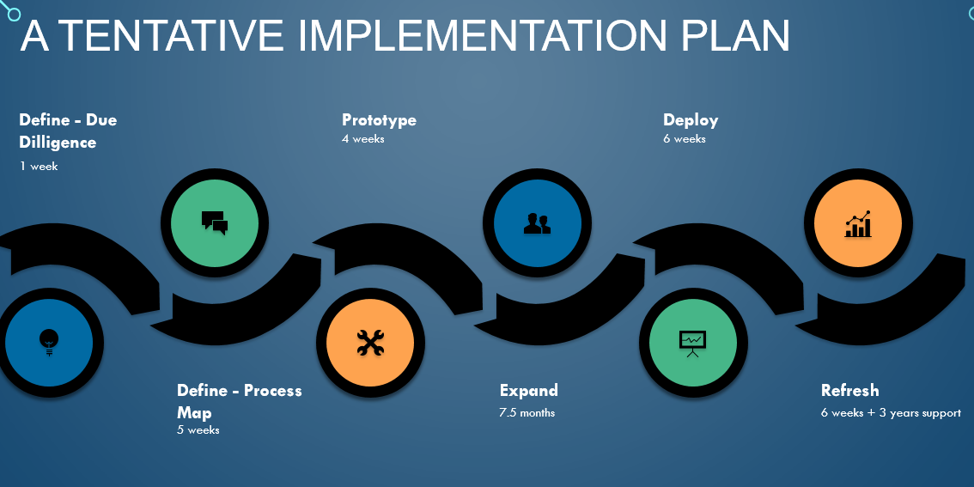

Post roll out we will be providing warranty support and 3 years support. During the support/maintenance phase any change request/major enhancements will undergo due change management process and estimated separately.

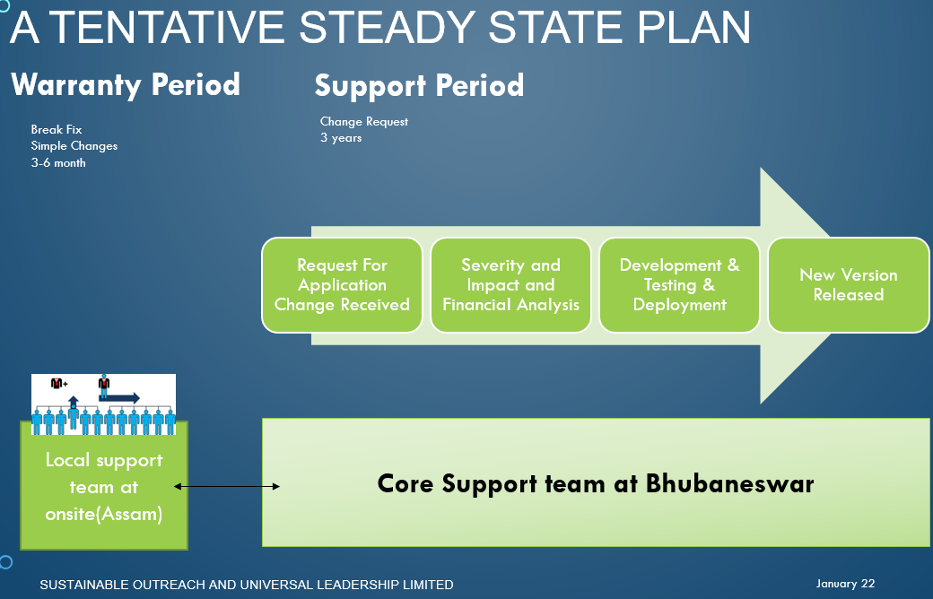

Assumptions

* We assume we will be getting access to SME during all phases of project.
* We assume infra will be provided by client.In case Soul willl setup infra the chnarges will be as per actual.

### **Construction ERP - Commercials**

|  |  |  |
| --- | --- | --- |
| **Sl. No** | **Cost Description** | **Cost (in INR)** |
| 1 | Initial set up cost include   * Due Diligence Assessment * POC and Sign Off * Training and Roll out to Assam Site * Final Go-Live. * 3 months Warranty support   Modules Included-   * HR * PAYROLL * ACCOUNTING * BUY * SELL * Purchase & Inventory * Project Management * Document Management * Workflow * Tendering * Budget and Estimation * Estimation * Reporting * Fixed Assets & Maintenance (Tools & Plants) * Inventory management * HELPDESK * Reporting and Analytics | 0.00 |
| 2 | Annual Maintenance Cost and Licensing Fee | 30% of initial set up cost |
| 3 | Application Hosting Cost | As actual |
| 4 | Misc. travel cost | 15% of total cost |
| 5 | Customization Cost (cost per person day of effort) | 0.0 |

### 

### **Terms & Conditions**

1. The quote above is exclusive of taxes like GST.
2. The minimum contract of 4 years is required.
3. Payment Terms for BRC:
4. 40% of total project cost as advance with PO
5. 20% will be paid after SRS
6. 20% after the required customization and development
7. 20% after Go-Live.
8. The estimation for customization will be done after further discussions between SOUL and BRC.
9. The system will be deployed in single-tenancy environment at customer preferred location in Assam.
10. BRC may have to re-engineer some of their processes. Since Construction ERP is built on best practices, we can assure that process re-engineering will result in better efficiency.
11. After user creation and role assignment and master data set up, system will be considered deployed.
12. Training will start after deployment and initial setup and we shall follow “Train the trainers” module for training purposes.
13. Support/ Usage Fee will be invoiced monthly in advance payable within 7 days of the invoice date.
14. Purchase Order and all Payments should be made in the name of “SUSTAINABLE OUTREACH AND UNIVERSIAL LEADERSHIP (SOUL) LIMITED” By Cheque or NEFT Payable at Bhubaneswar.
15. AMC includes onsite support services.
16. We recommend a monthly meeting between all stake holders to ensure issue resolution.